EXPERIMENT – 5

EXP No: 5

Date: ___________

Title
DML Commands – WHERE and LIKE Clauses

AIM
To retrieve records from the Drone Delivery Management System using WHERE and LIKE clauses.

DESCRIPTION
The WHERE clause filters records based on a specified condition, while the LIKE clause is used to search for a specified pattern in a column.

PROCEDURE
- Open MySQL Command Line.
- Select the DroneDelivery database.
- Execute SELECT queries using WHERE and LIKE.
- Display the filtered records.

Query 1

USE DroneDelivery;

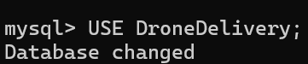

Query 2

SELECT *

FROM Customers

WHERE Address='Hyderabad';

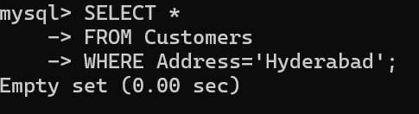

Query 3

SELECT *

FROM Drones

WHERE DroneStatus='Available';

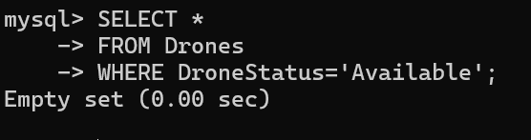

Query 4

SELECT *

FROM Deliveries

WHERE DeliveryStatus='Delivered';

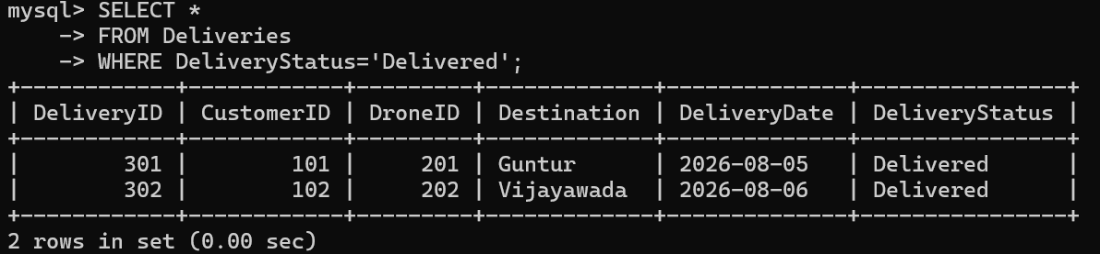

Query 5

SELECT *

FROM Customers

WHERE CustomerName LIKE 'R%';

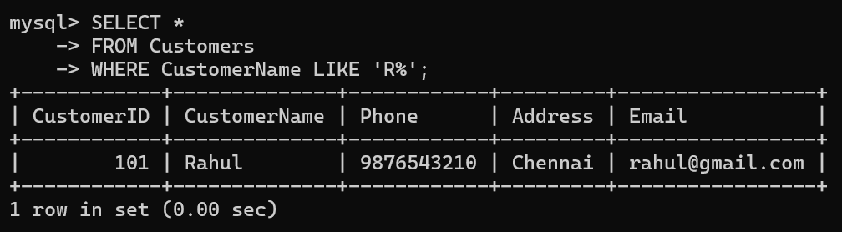

Query 6

SELECT *

FROM Drones

WHERE DroneModel LIKE '%Pro';

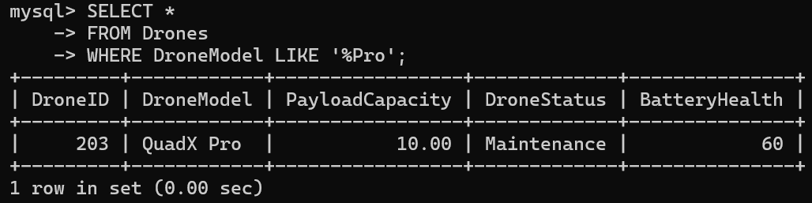

Query 7

SELECT *

FROM Deliveries

WHERE Destination LIKE '%tur%';

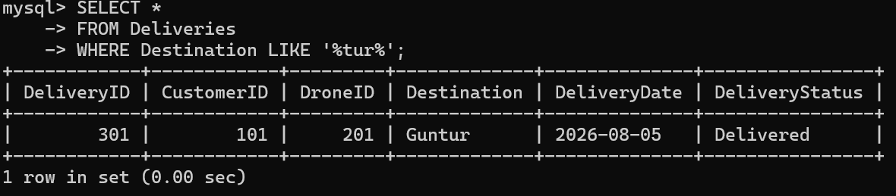

Query 8

SELECT *

FROM Customers

WHERE Phone LIKE '98%';

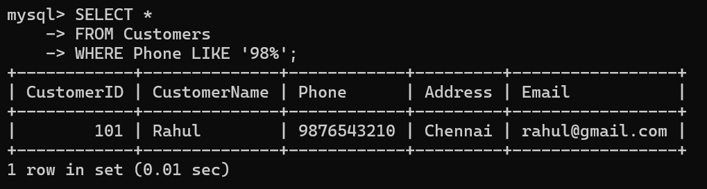

Query 9

SELECT *

FROM Drones

WHERE PayloadCapacity > 6;

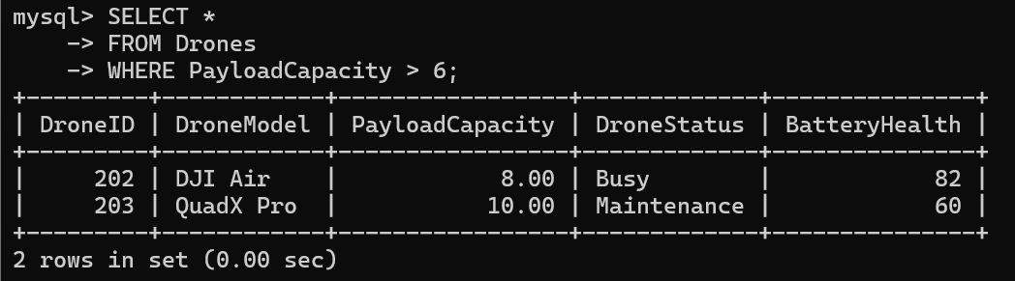

Query 10

SELECT *

FROM Deliveries

WHERE DeliveryID > 301;
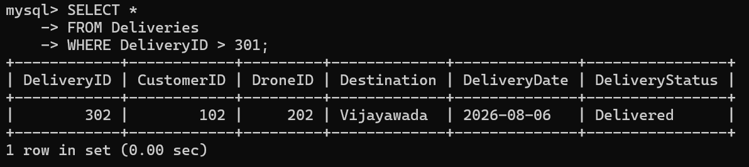

RESULT
Thus, the WHERE and LIKE clauses were successfully used to retrieve the required records from the Drone Delivery Management System database.

